**AWS S3**

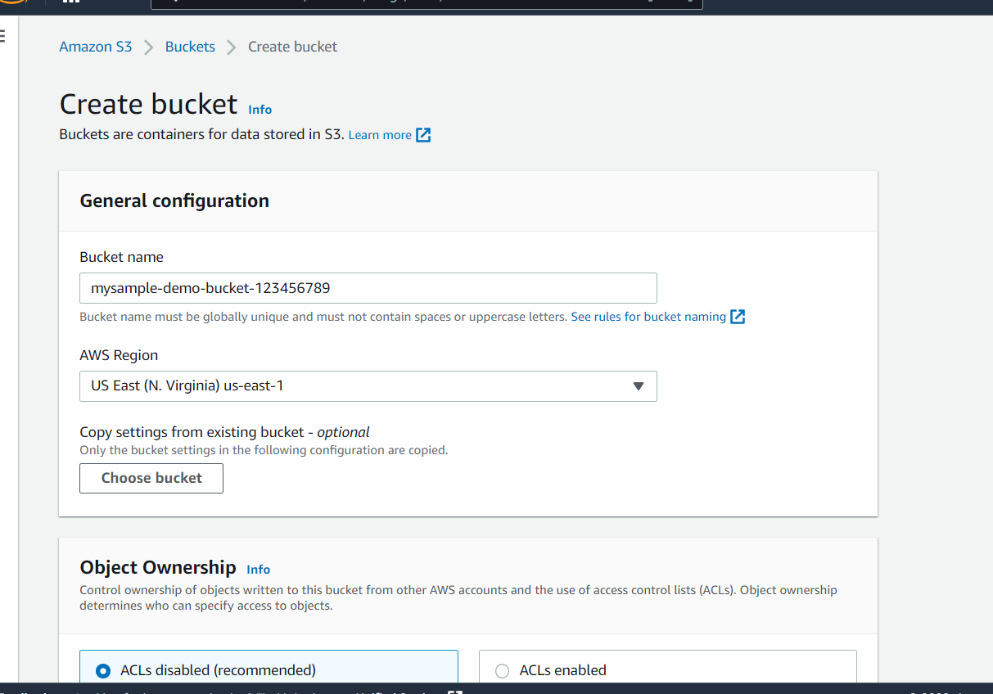

Go to s3 buckets and click on create bucket and enter bucket name and create

Created with default settings

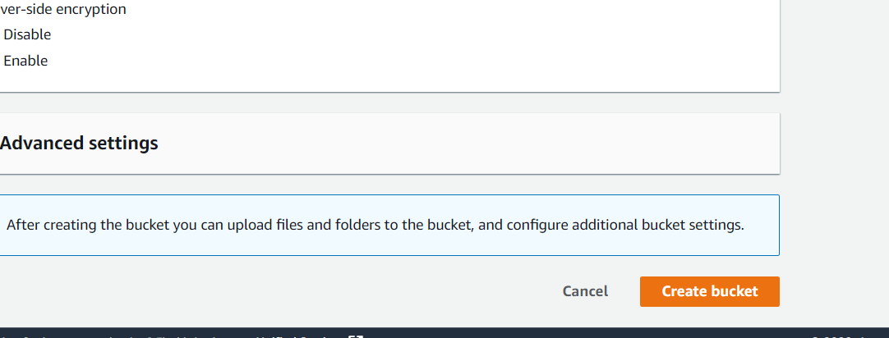

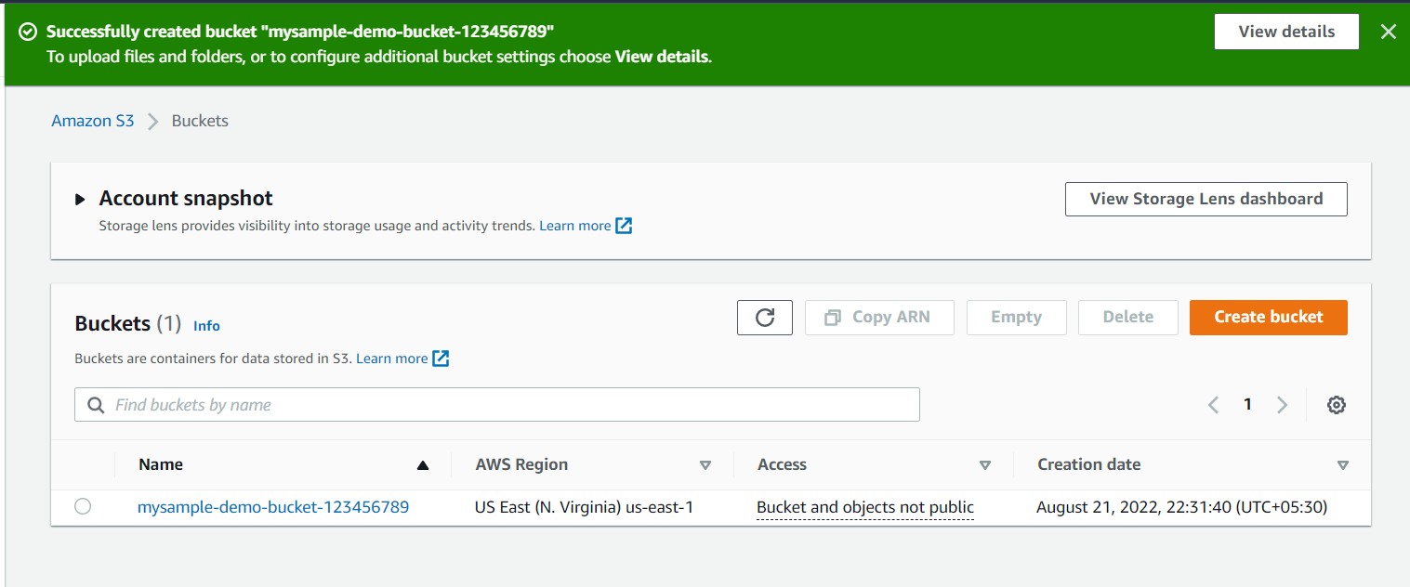

Shows a successful response after creation

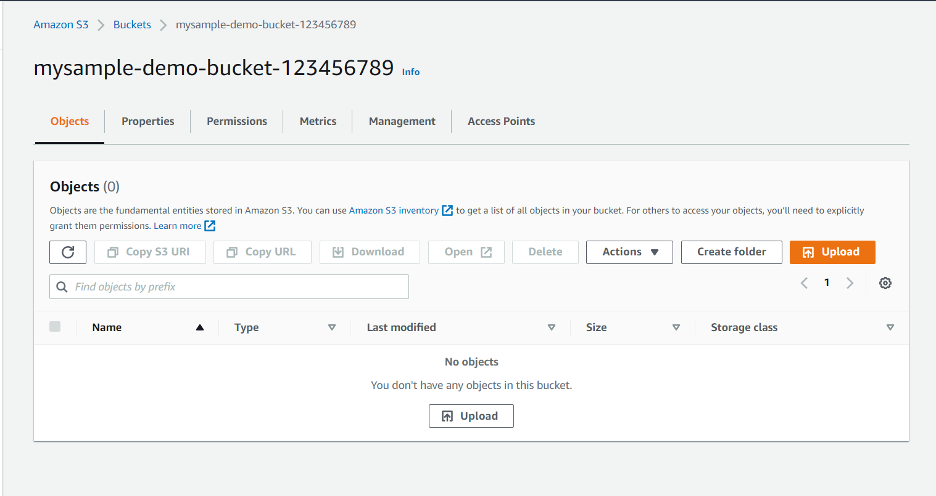

Now ready to add data objects

Click on the upload button to upload objects

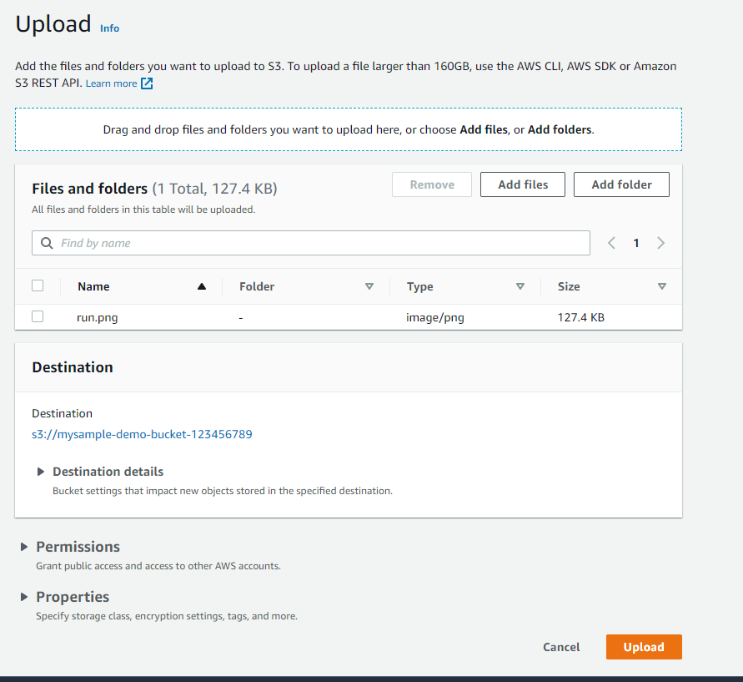

Click on add files and select files or objects that to be added and hit upload

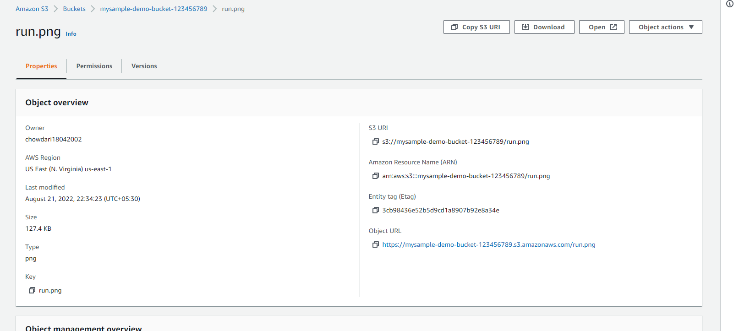

The detailed information of the object is can be vied when we click on the created object

We can create a temporary URL to view the files that the blocked for public access

We can delete and create the multiple objects and they can be organised in folders

Finally to delete the bucket the bucket must be empty so firstly we should empty the bucket and only then we can delete the bucket created.

**LAMBDA**

Go to AWS services and select lambda and create a function

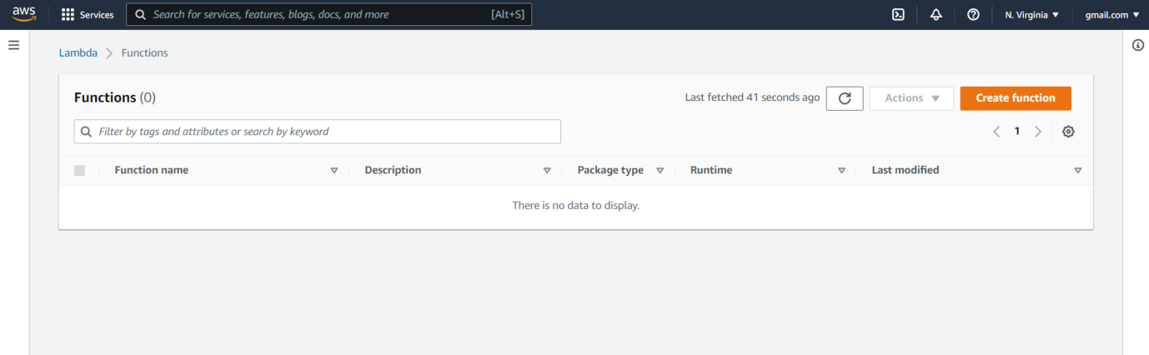

There will be a pre written code and you can modify it in lambda_function

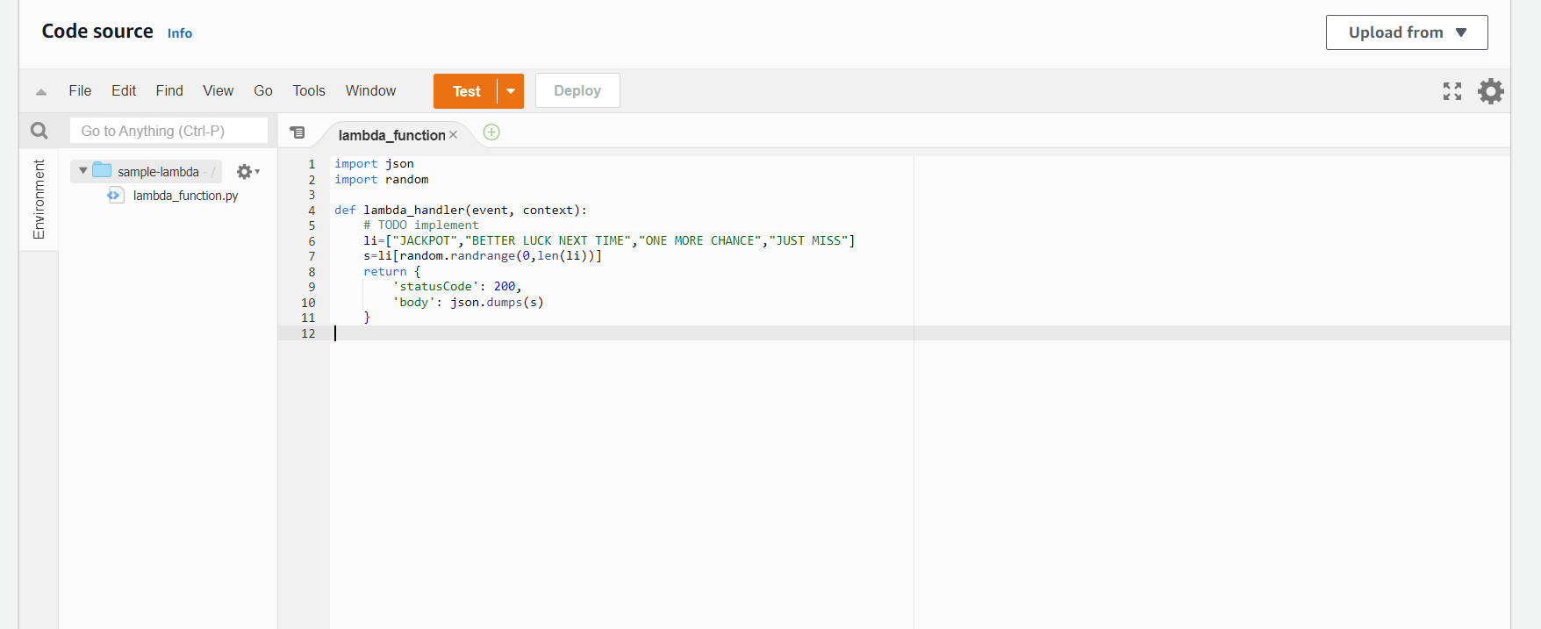

Click on add trigger and add a API gateway

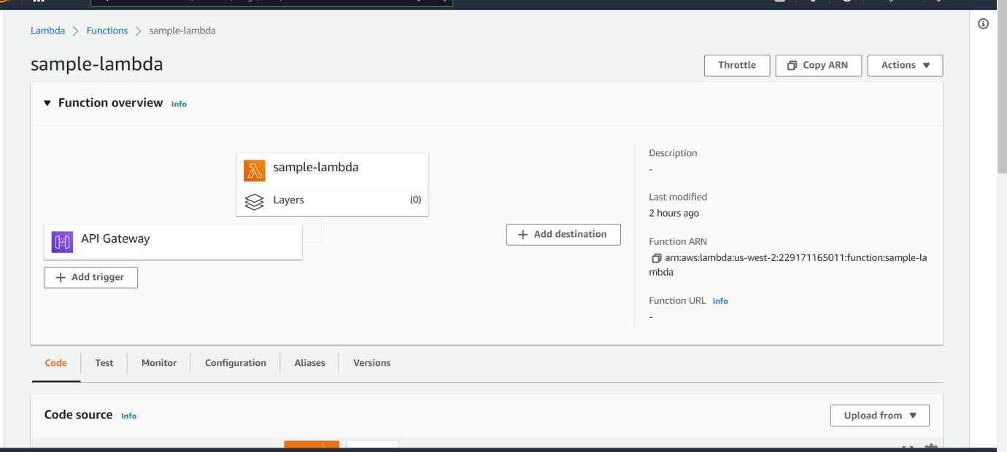

Configure the test event

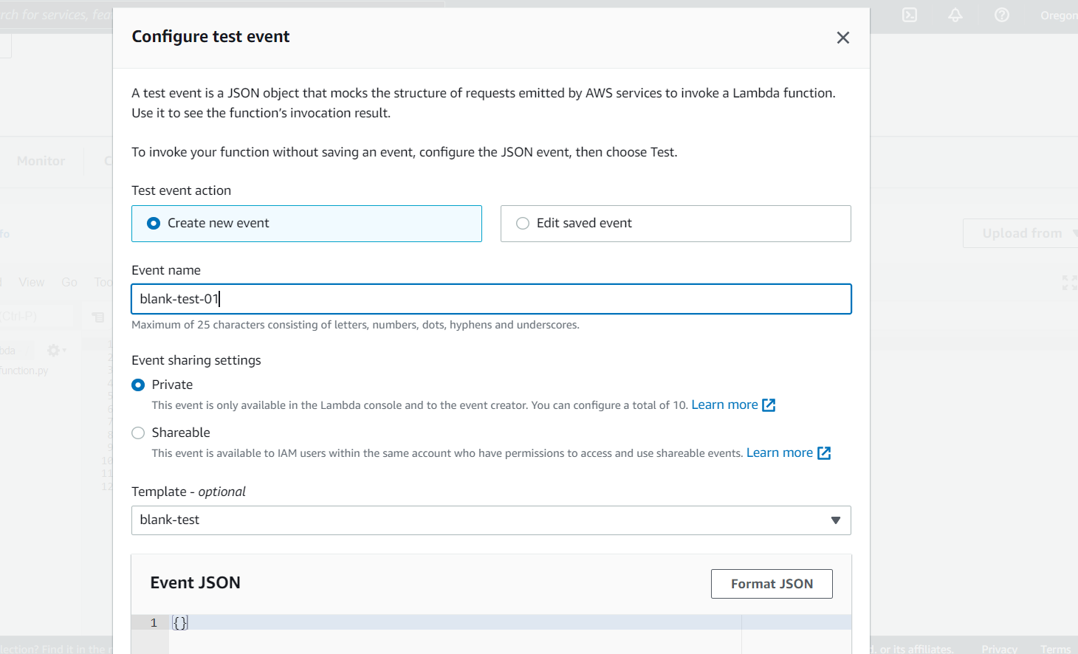

Now save the changes test the code and the code result will be obtained

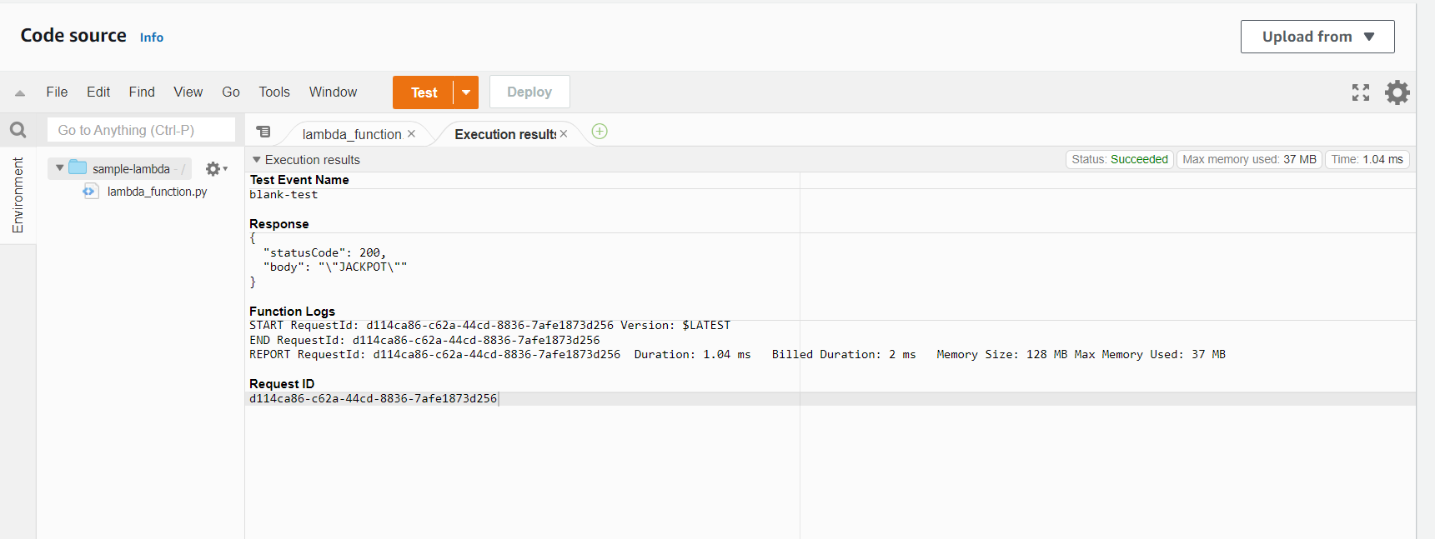

Now time to deploy and hit deploy button

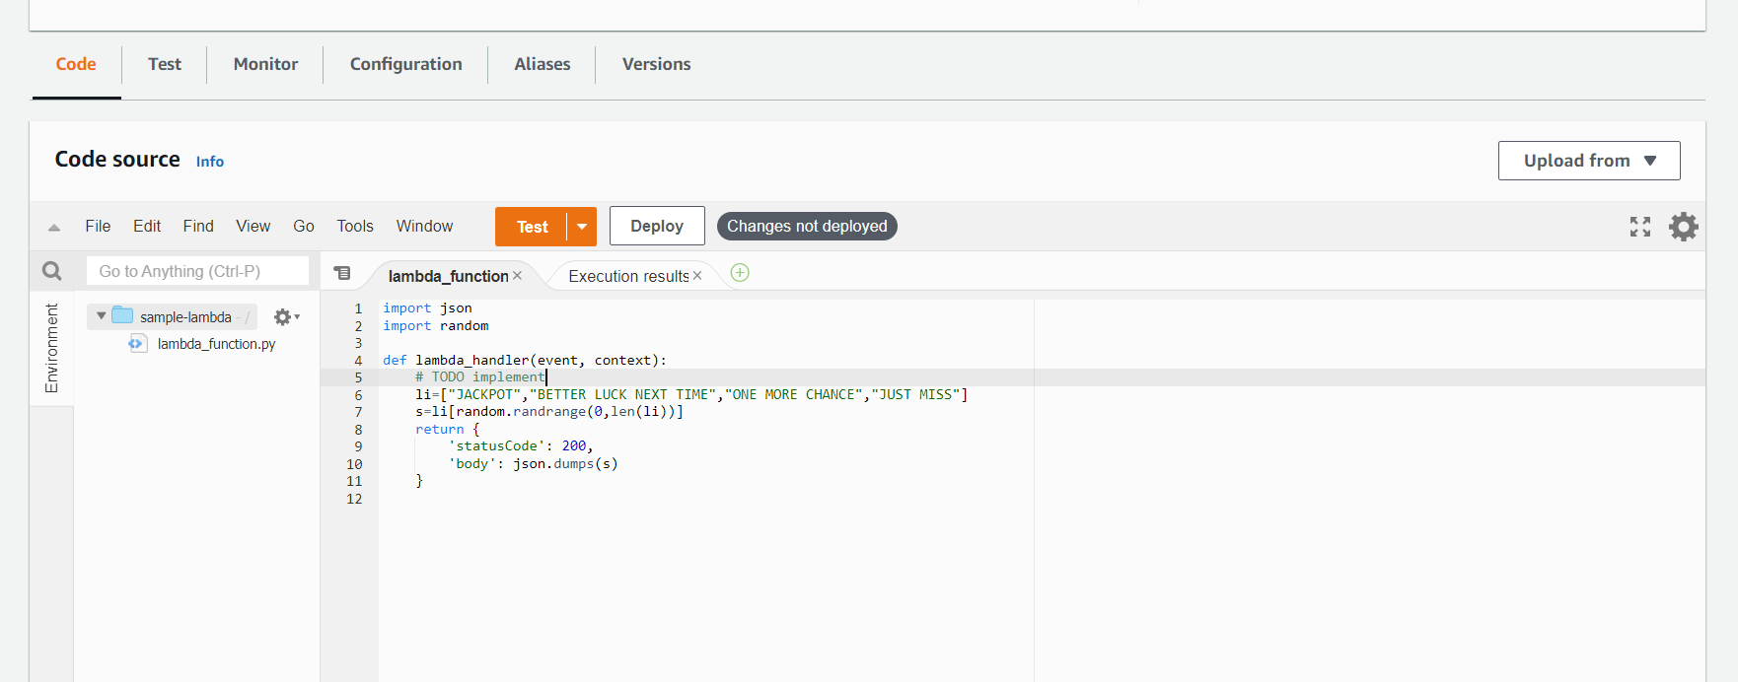

Now select the configuration in the content bar and open the link

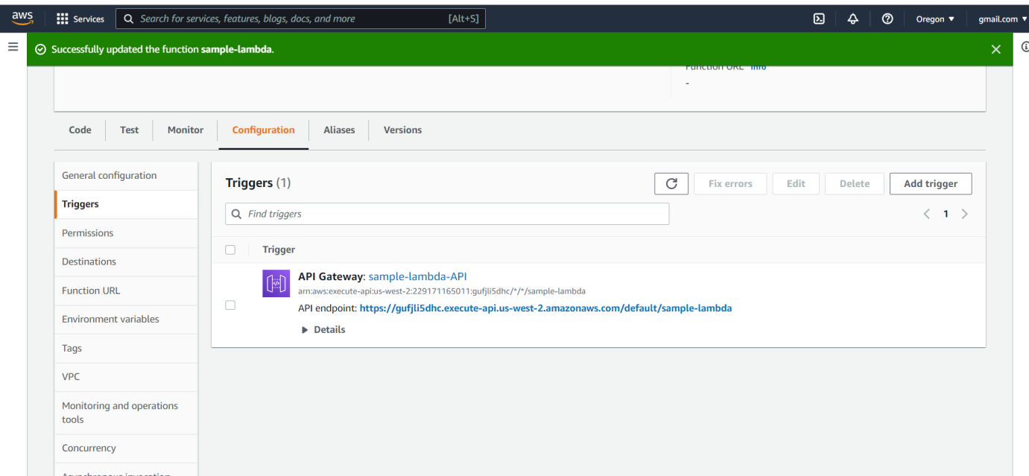

The API responses is obtained

